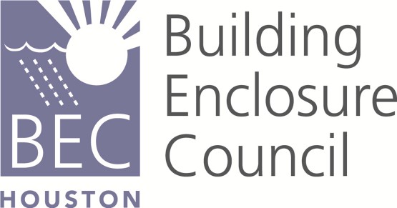

BEC Houston Presents:
Tapered Polyiso Roof Insulation
This presentation provides an overview of the art and science of tapered polyiso roof insulation systems, roof membrane durability, positive drainage, and key features of sustainable roof systems.

Tuesday, October 20 – 5:30 to 6:00 Networking

6:00 to 7:00PM Presentation
Location: AIA Houston 315 Capitol, Suite 120, Houston, TX 77002
Please join us as we continue our series of presentations. $20.00 registration fee for non-member guests, free for students and interns. If you are getting this email you are a BEC member or may have attended an event in the past. To register online go to the AIA website and find the link in upcoming events.

Presenter – Shaun Kerschen - currently the Private Labels Sales manager and the Tapered Services Manager with the Atlas Roofing Corporation. He has over 13 years of extensive experience designing, estimating, and educating the industry on tapered EPS and Polyiso roof insulation systems. Shaun has also been involved with many of the industry organizations such as RCI, CSI, SPRI, and PIMA.
Learning Objectives:

Describe the key components of a polyisocyanurate (polyiso) tapered roof insulation system, the energy efficiency associated with it, its embodied energy, and its positive life cycle.
Understand roof slope and the slope options available in roof system design.
Understand the purposes of tapered polyiso roof insulation and the benefits to roof system durability
Understand the benefits of pre-fabricated roof crickets, miters, and drain sumps
This course has been registered for 1.0 CES AIA credit.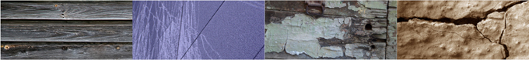 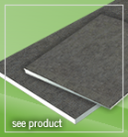
2015 BEC HOUSTON MAJOR SPONSORS:

